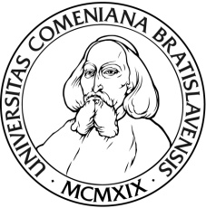  Application Form - Master Degree Program |  | 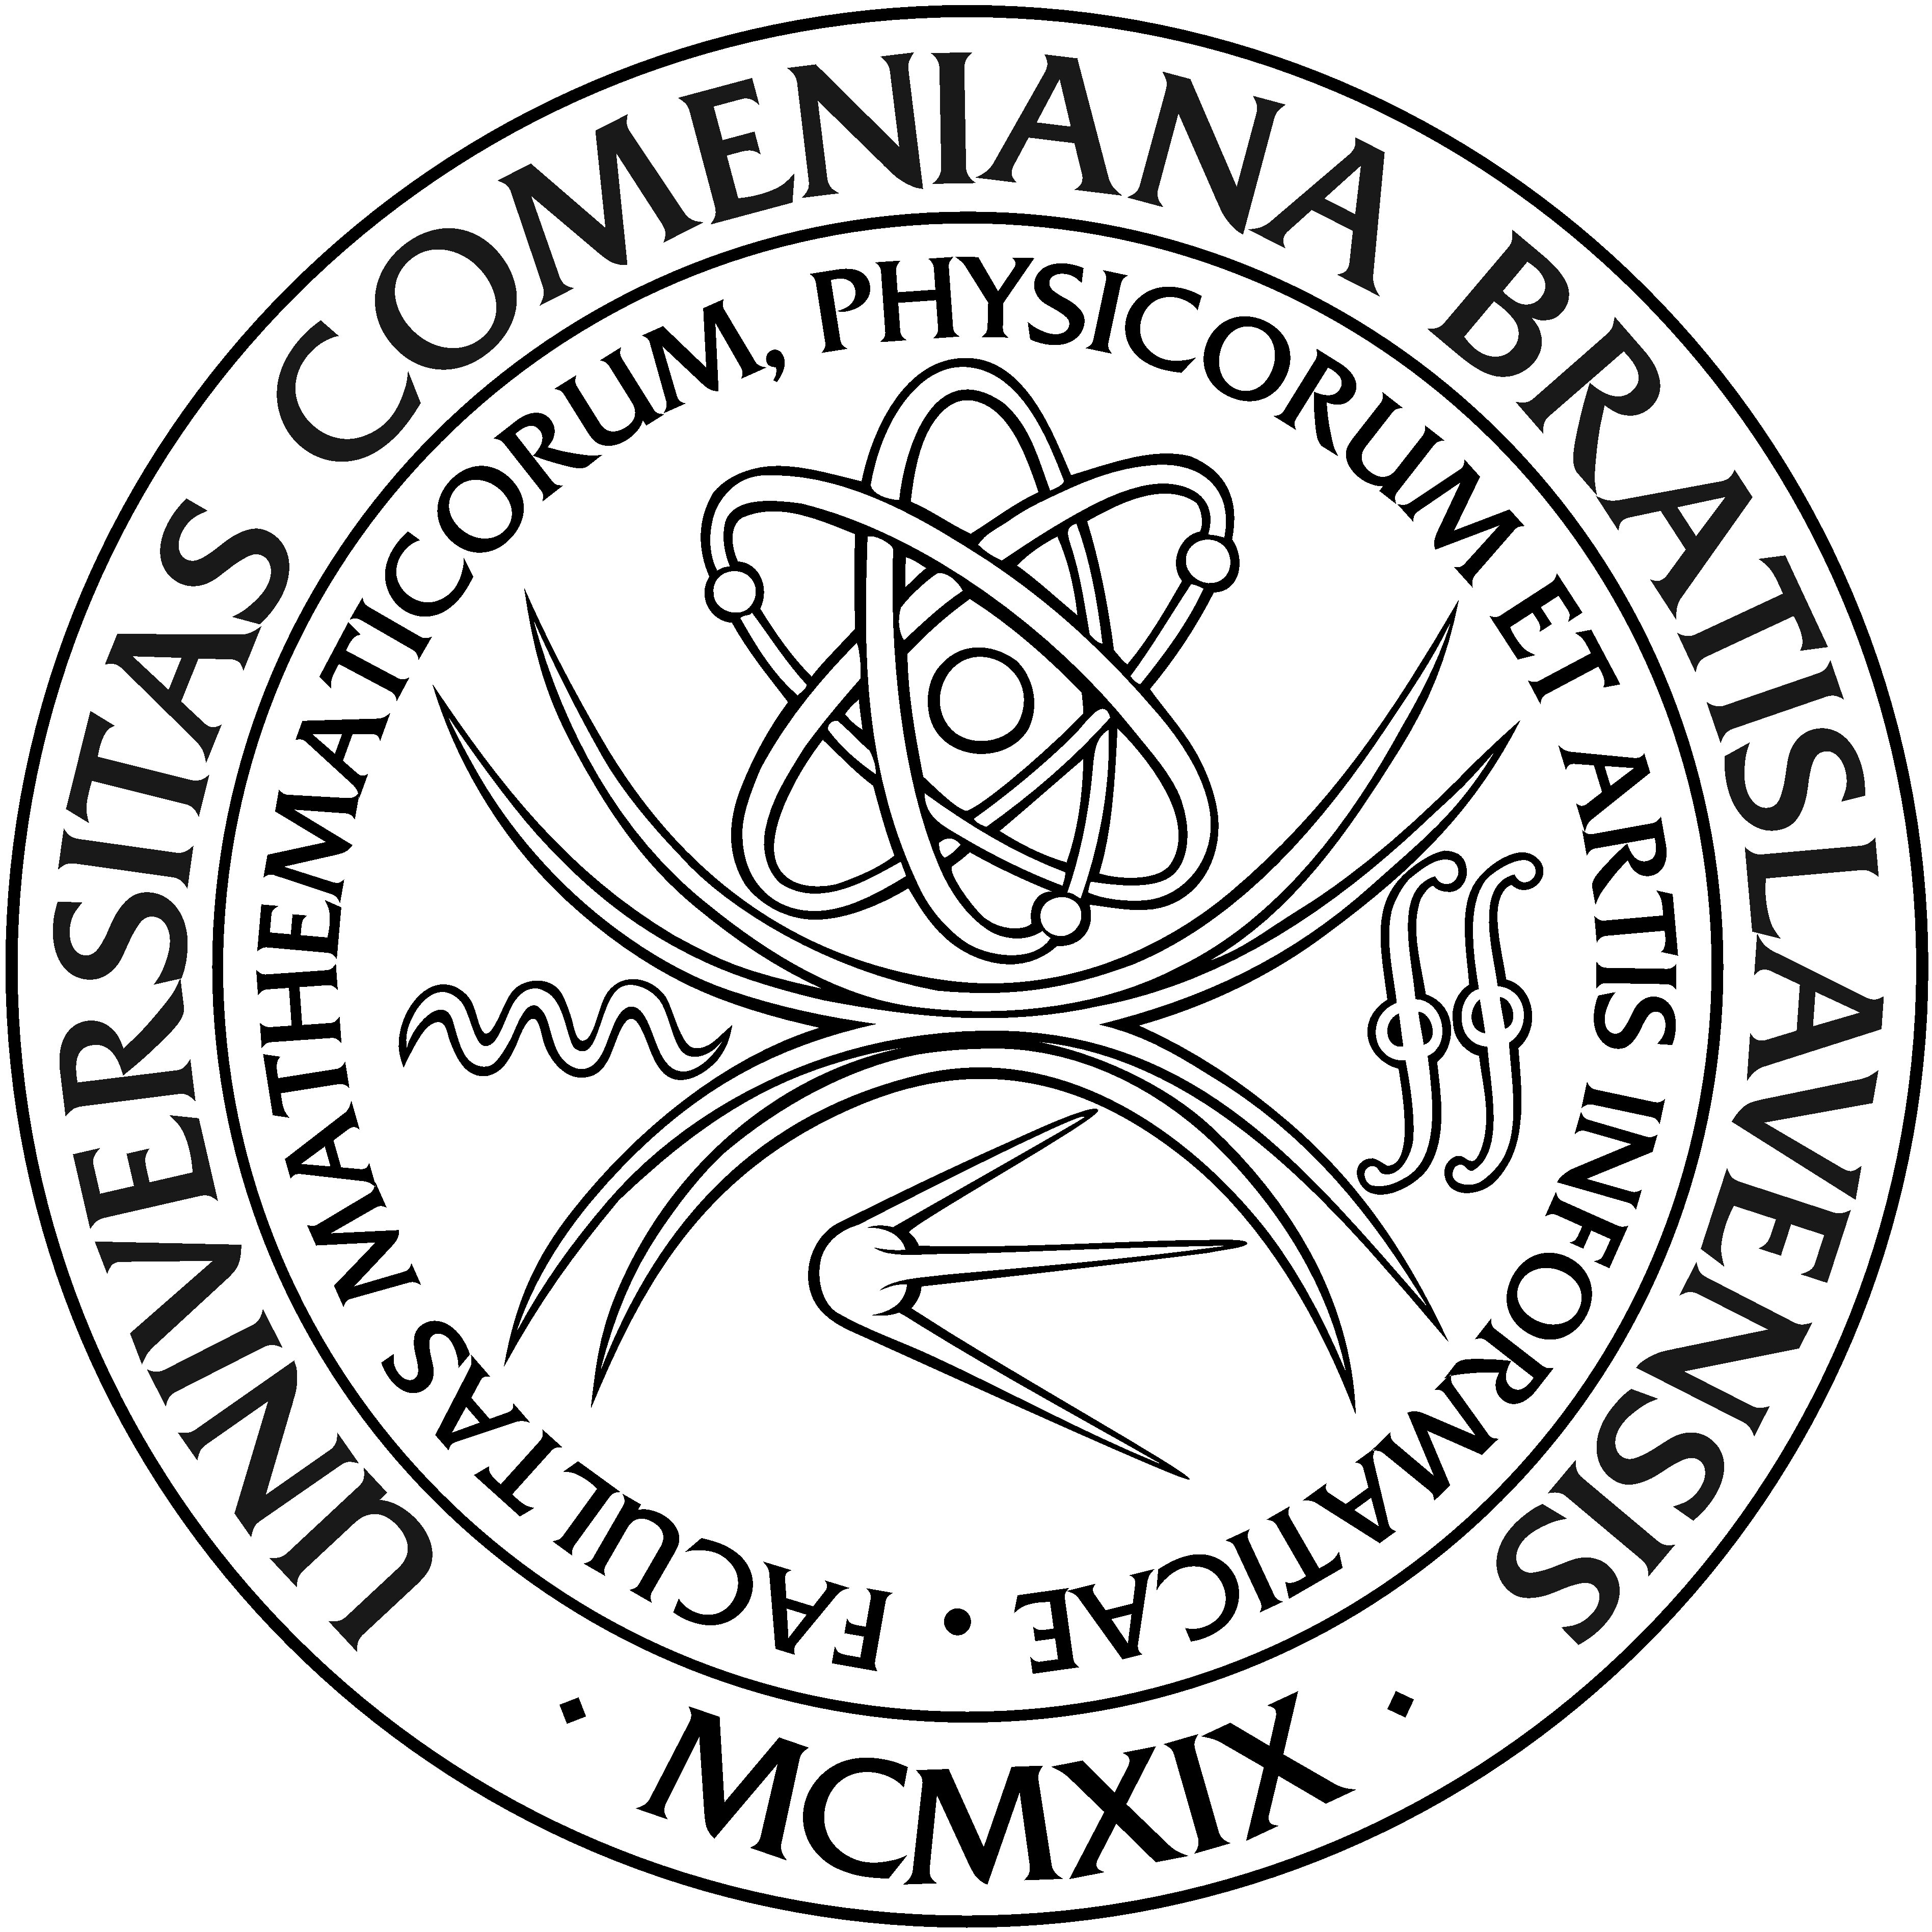

Personal Details
Family Name: | Slovak Birth Registration Number  (if applicable):
Given Name: | Date of Birth (day/month/year):
Maiden Name: | Place of Birth:
Nationality: | Country of Birth:
Citizenship: | Slovak Identity Card Number  (if applicable):
Residence Permit Number  (if applicable): | Country of Passport and Passport Number:

Contact Details:
e-mail: | Telephone:
Permanent Residence Address:

Street, House, Number:

Town / City:

District (State):

ZIP: | Country:

Study program
University: Comenius university
Faculty: Faculty of Mathematics, Physics and Informatics

Study program 1:

Study program 2:

Study program 3:

A Education
A1 Highest Level of Education Completed or In Progress:
University:

Faculty / School:

Major Area of Study:

Address:

Degree Achieved:

Year of Graduation (expected if not completed yet): | Number of years of work experience related to specialization:

A2 Highest Level of Incomplete Education:
University:

Faculty / School:

Major Area of Study:

Address:

Degree:

Years of Study: | Number of years of work experience related to specialization:

Language skills:

English – Native speaker and / or previous university education in English (yes / no):

English Language Certificate (if ’no’ stated above):

Other Languages / level of proficiency:

I declare, that all of the information above is correct and that I am aware of tuition fee schedule.

Date:
Applicant’s Signature:............................................................

Attachements:
- Legalized copy of bachelor´s degree diploma (in English) – a student who has already completed his/her bachelor study, otherwise
Confirmation of study towards university degree (in English)
- Official transcript of completed courses during the bachelor study
- Internationally recognized English language certificate (copy)
- Structured CV in English.
- Copy of passport.
- Two academic reference letters in English
- Motivation letter in English
- Confirmation of administration fee payment (copy)

